**Login Page**

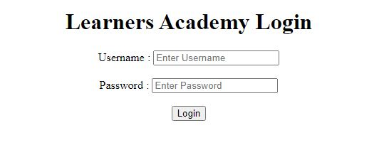

**Now enter Username and Password as admin.**

**Now this page will open.**

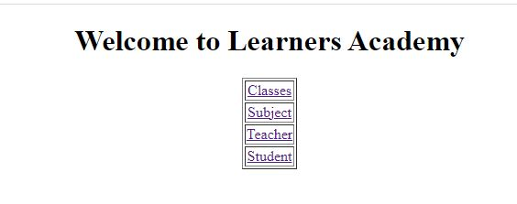

**After Clicking on Classes this page will open where we can Add, Edit or Delete a Record.**

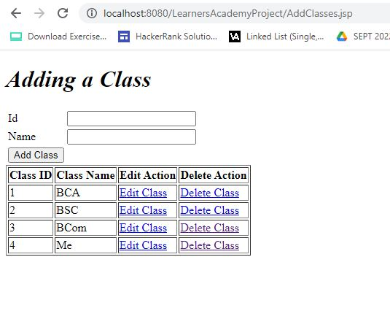

**After clicking Edit class this page will appear. Here user need to fill the new name and click on Edit Now.**

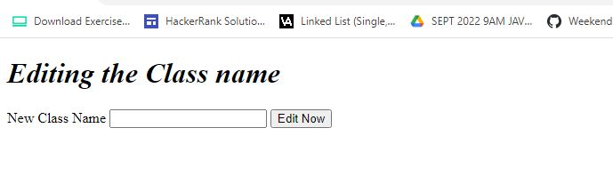

**After clicking Edit Now below page will appear.**

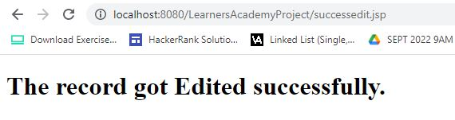

**After Clicking on Delete Class below page will appear. Enter the class name and it will get deleted.**

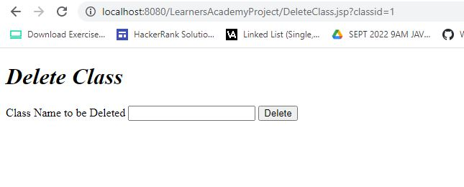

**On Main Page after clicking on Subject below page will appear. Here user can Add, Edit or Delete the Subject.**

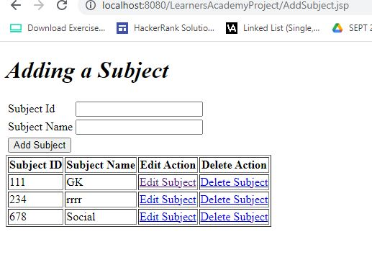

**After Clicking on Edit Subject below page will appear. Here user can Edit Subject name.**

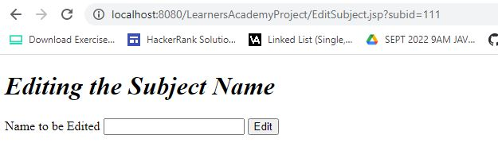

**After Clicking on Delete Subject below page will appear.**

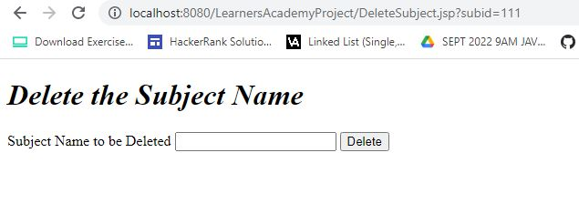

**On Main Page after clicking on Teachers we get the following page where we can Add, Edit and Delete Teachers record.**

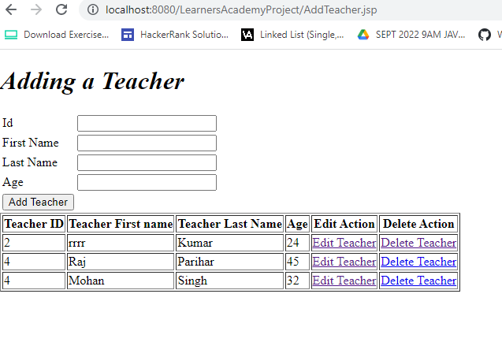

**On clicking Edit Teacher we can edit the teachers information and the following page appears.**

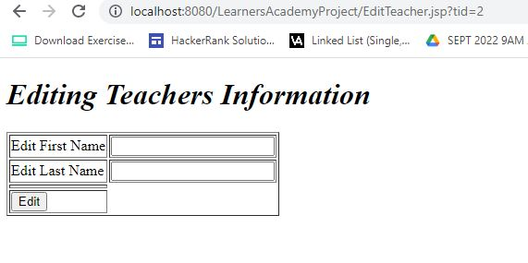

**After clicking on Delete Teacher the following page appears where we can delete Teacher information**

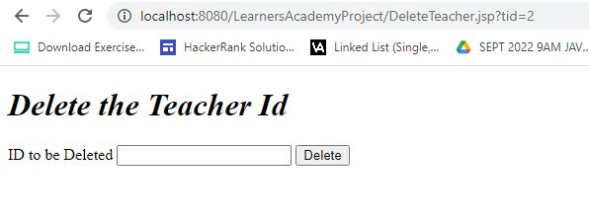

**On Main page after clicking on Students we get the following page.**

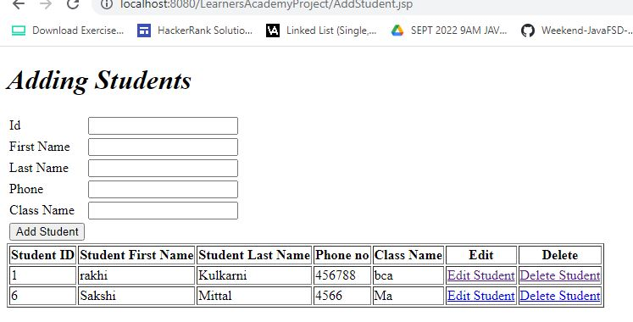

**By clicking Edit Student we can edit student information.**

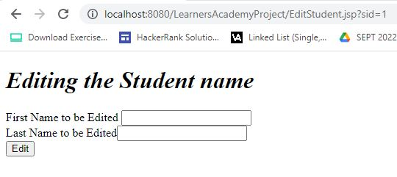

**On clicking Delete Student we can delete student information.**

